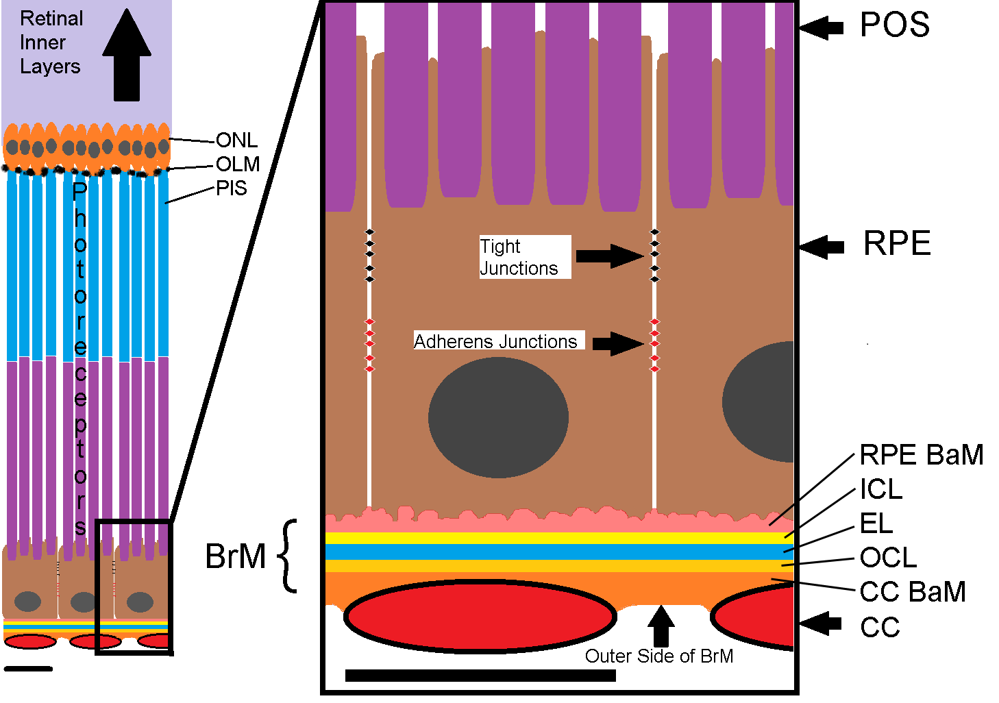
Figure 1. Retinal Structure, the Retinal Pigment Epithelium, Bruch’s Membrane and the Choriocapillaris. Left large-scale: Structure of the outer retinal layers, the RPE and the CC. Right: Detail of the CC-BrM-RPE-POS complex. CC: choriocapillaris, BrM: Bruch’s membrane, RPE: Retinal pigment epithelium, CC BaM: Basement membrane of the CC, OCL: Outer collagenous layer, EL: Elastin layer, ICL: Inner collagenous layer, RPE BaM: Basement membrane of the RPE (we abbreviate RPE BaM as RBaM), POS: Photoreceptor outer segment, PIS: Photoreceptor inner segment, ONL: Outer nuclear layer. Light purple shading indicates the location of the inner retina. Scale bars ~ 10 µm.

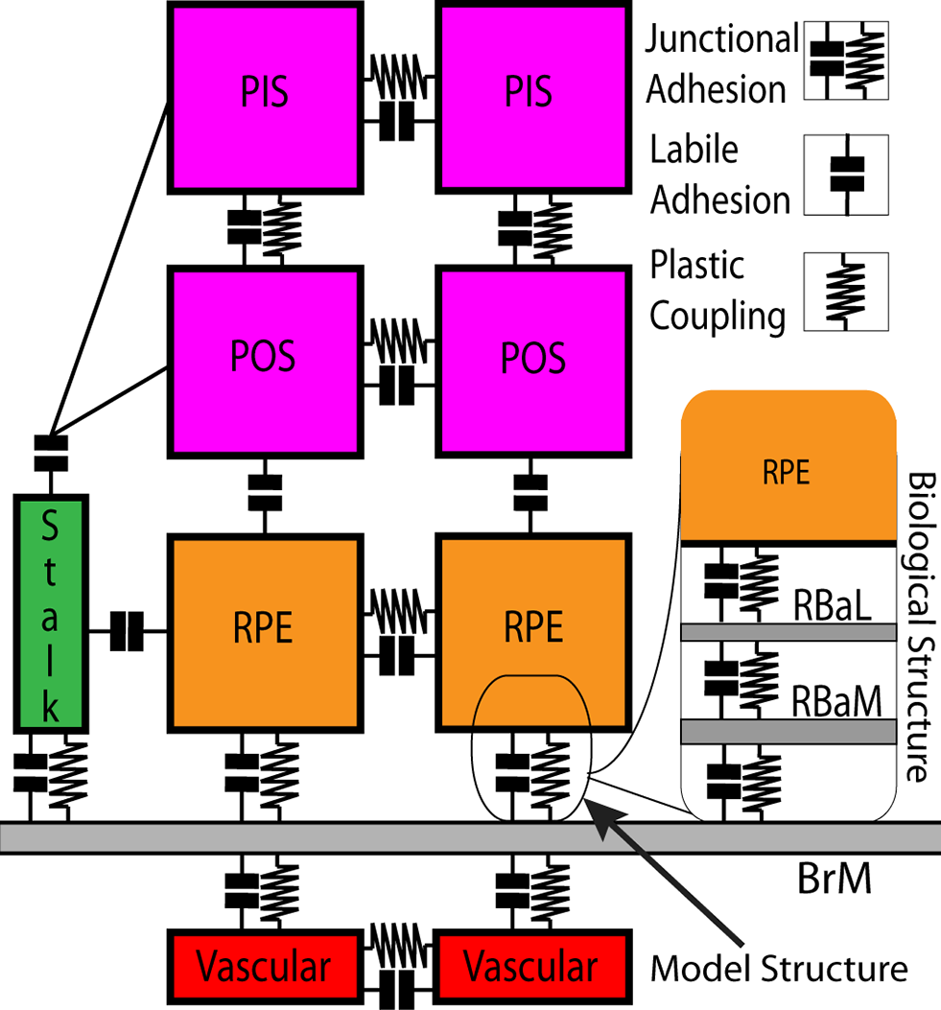
Figure 2. Adhesive Interaction Processes in the Model Retina. Our model includes two types of cell-cell and cell-BrM adhesion: 1) labile adhesion and 2) junctional adhesion. Modeled labile adhesion represents cell-cell or cell-ECM labile adhesion in the absence of strong junctional structures (e.g., RPE-POS adhesion). Junctional adhesion combines labile adhesion at cell boundaries with plastic coupling (e.g., between neighboring cells or between BrM and cells). Plastic coupling simulates cytoskeletally-coupled junctional structures as breakable springs (see the Error: Reference source not found section) that mechanically connect neighboring cells and also connect cells to BrM. Junctional adhesion represents biological epithelial or endothelial junctional adhesion or cell-ECM focal adhesion. In the model, a single junctional adhesion between RPE cells and BrM represents the complex biological adhesion between RPE cells and their basal laminae (RBaL), adhesion between the basal laminae and their basement membrane (RBaM) and adhesion between RBaM and BrM (inset). Modeled adhesion processes are: EC-EC and EC-BrM junctional adhesion; EC-RPE, EC-POS and EC-PIS labile adhesion; RPE-RPE and RPE-BrM junctional adhesion; RPE-PIS and RPE-POS labile adhesion; PIS-PIS, PIS-POS and POS-POS junctional adhesion. Key: BrM: Bruch’s membrane, RPE: retinal pigment epithelium, RBaM: basement membrane of the RPE, RBaL: basal lamina of the RPE, POS: photoreceptor outer segment, PIS: photoreceptor inner segment.

Cell Types | Stalk | BrM | RPE | POS | PIS | Medium
Stalk | -20 | -10 | -10 | -10 | -10 | 3
BrM |  | -12 | -38/-28/-18 | 0 | 0 | -1
RPE |  |  | -40/-18 | -16/-1 | -16/-1 | 3
POS |  |  |  | -16 | -16 | 3
PIS |  |  |  |  | -16 | 3
Medium |  |  |  |  |  | 0
Table 1. Labile Adhesion Parameters (Contact Energies). Negative contact energies represent adhesive interactions; positive contact energies represent repulsive interactions. More negative contact energies indicate stronger adhesive interactions. (/) separates the reference, moderately impaired and severely impaired levels of labile adhesion.

 |  | Labile Adhesion Strength
Cell-Type Pairs |  | Normal: 3 | Moderately Impaired: 2 | Severely Impaired: 1
RPE-RPE | RRl | -40 | - | -18
RPE-BrM | RBl | -38 | -28 | -18
RPE-POS | ROl | -16 | - | -1
POS-POS | - | -16 | - | -
PIS-PIS | - | -16 | - | -
Table 2. Labile Adhesion Strengths (Contact Energies). More negative contact energies indicate stronger adhesive interactions. (-) denotes labile adhesion strengths not used in our simulations.

 |  | Plastic coupling strength levels
Cell-Type Pairs | Name | Normal: 3 | Impaired: 2 | Severely Impaired: 1
RPE-RPE | RRp | 300 | 60 | 30
RPE-BrM | RBp | 300 | 60 | 30
POS-POS | - | 30 | - | -
PIS-PIS | - | 30 | - | -
PIS-POS | - | 30 | - | -
Vascular-Vascular | - | 200 | - | -
Stalk-Vascular | - | 150 | - | -
Tip-Vascular | - | 50 | - | -
Stalk-Stalk | - | 50 | - | -
Stalk-Tip | - | 50 | - | -
Vascular-BrM | - | 200 | - | -
Stalk-BrM | - | 25 | - | -
Tip-BrM | - | 25 | - | -
Table 3. Plastic Coupling Strengths () Links Between Cell-Type Pairs. Larger plastic coupling strengths represent stiffer linear springs. (-) denotes values of not used in our simulations.

