Example: Model Development Workflow for the Changes of Shape of Epithelial Cells due to Cell Cycle Progression

Working from the published article:
Nematbakhsh, Ali, Wenzhao Sun, Pavel A. Brodskiy, Aboutaleb Amiri, Cody Narciso, Zhiliang Xu, Jeremiah J. Zartman, and Mark Alber. "Multi-scale computational study of the mechanical regulation of cell mitotic rounding in epithelia." PLOS Computational Biology 13, no. 5 (2017): e1005533.

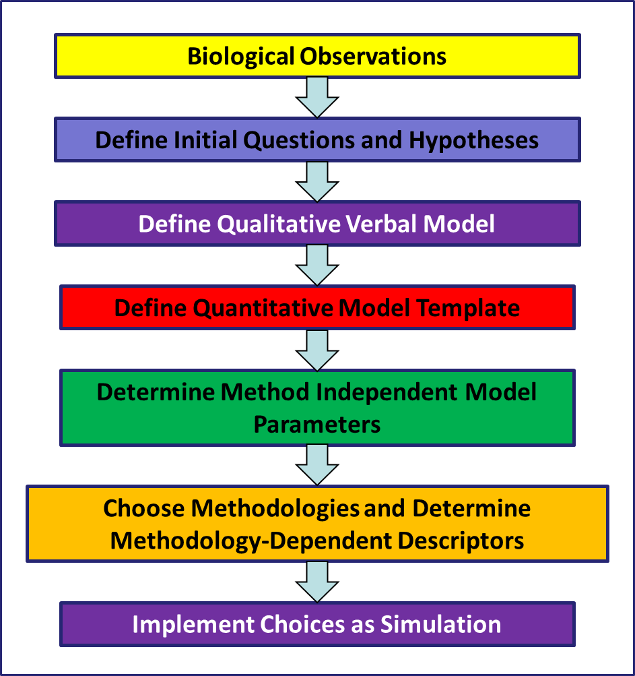
Biological Observations

Apical surface of epithelial sheet in the wing disc of Drosophila with some cells undergoing mitosis. Fluorescent tag is GFP associated with E-cadherin, a protein responsible for forming impermeable connections between cells.
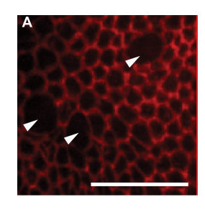

(http://journals.plos.org/ploscompbiol/article?id=10.1371/journal.pcbi.1005533)

Initial Questions
Observables:
From the images can determine cell’s shape, i.e PERIMETER and SURFACE AREA and nature of ADHESION values. We infer the CELL CYCLE STATE of the Cell from the configuration, but we can’t measure it directly.
General Questions:
All cells are not undergoing mitosis at the same time. But when they are, cells increase their apical surface area and become more round. They also seem to lose their adhesivity to neighbouring cells.

What is going on at the level of each individual cell?

Defining Questions and Hypotheses
Problem: Why do Epithelial Cells entering mitosis become rounder and also decrease their adhesion to other cells?

Governing Hypothesis: Increase in the cortical stiffness of the underlying actomyosin ring from the increased mass during mitosis results in the adjustment of shape. This also leads to reduced intracellular pressure reducing adhesion strengths.

The changes in stiffness can be connected to an internal clock which cells use to keep track of time and division.

Defining Qualitative Verbal Model
Objects: Cells (Representing apical domains in Epithelia)
What are the Properties of our cells?
Shape
[Mass]—not observed but inferred from
Perimeter Length
Surface Area
Cell Cycle Progression State {Interphase, Mitosis}

What are the Behaviors of our cells?
Cells vary their cortical stiffness depending on their Cell Cycle Progression State, specifically cells increase their cortical stiffness when their Cell Cycle Progression State reaches mitosis.
Cells’ Mass increases as their Cell Cycle Progression State increases
Cells divide when their Cell Cycle Progression State reaches mitosis
After Division, Cell Cycle Progression resets to Interphase

What are the Interactions between our cells?
Cells adhere to neighboring cells by forming adhesive junctions, cells reduce their adherence when their Cell Cycle Progression State reaches mitosis

What are the Initial/Boundary Conditions and Tweaks?
Initial Conditions:
A fixed number of cells adjacent to each other, all with Cell Cycle Progression State set to Interphase
Boundary:
An infinite universe
Tweaks:
None

What are the Dynamics of the cells?
The Cell Cycle Progression State increases stochastically in time
Cells adjust their shapes in response to the forces acting on them internally and externally
Cells change their cortical stiffness and adhesivity when their Cell Cycle Progression State reaches mitosis

Express Qualitative Verbal Model as tables

Object | Properties | Property Type | Annotation on Terminology | Source Reference
Universe  (Medium) |  |  | MESH:D004777 | https://link.springer.com/protocol/10.1007/978-1-59745-525-1_13 | New Concept but could be related to source in link
 | X-extent | Parameter | SIO:000400  PATO:0001708 | https://link.springer.com/protocol/10.1007/978-1-59745-525-1_13 | New Concept but could be related to source in link
 | Y-extent | Parameter | SIO:000401  PATO:0001708 | https://link.springer.com/protocol/10.1007/978-1-59745-525-1_13 | New Concept but could be related to source in link
 | Z-extent | Parameter | SIO:000402  PATO:0001708 | https://link.springer.com/protocol/10.1007/978-1-59745-525-1_13 | New Concept but could be related to source in link
Cell |  |  | CL:0000000 | http://journals.plos.org/ploscompbiol/article?id=10.1371/journal.pcbi.1005533  https://www.ncbi.nlm.nih.gov/pmc/articles/PMC3612985/
 | Perimeter(L) | Variable | SIO:000046 | https://link.springer.com/protocol/10.1007/978-1-59745-525-1_13 | New Concept but could be related to source in link
 | Surface Area(SA) | Variable | MESH:D001830 | https://link.springer.com/protocol/10.1007/978-1-59745-525-1_13 | New Concept but could be related to source in link
 | Cell Cycle Progression  (CP) | Variable | MESH:D002453  Thesaurus:C25630 | http://journals.plos.org/ploscompbiol/article?id=10.1371/journal.pcbi.1005533

Behavior | Participant Object | Properties
Cell Growth | Cell | Surface Area(SA)
Cell Division | Cell | Surface Area(SA)
Cortical Stiffness($C_{t}$) | Cell | Perimeter(L)

Interaction | Participant Objects | Properties | Property Type
Formation of Adhesive Junctions | Cell 1 with Cell 2 if neighbours | Adhesion Strength(S) | Parameter

Dynamics | Participant Objects | Participant Behavior/Interactions | Property Affected
Stochastic Transition from Interphase to Mitosis | Cells | Cortical Stiffness,Growth,Division | Cell Cycle Progression(CP),Surface Area(SA)
Dynamics of Cortical Stiffness | Cells | Adhesion Between Cells | Perimeter(L), Adhesion Strength(S)

Define Quantitative Model Template

Cell Cycle Progression as a function of random growth :
$CP→CP+η$
Surface Area Changes:
$S→\left(CP+1\right)S_{initial}$
Cortical Stiffness Changes:
$C_{t}→\left(1-CP\right)C_{t}$
This affects perimeter:
$L→{C_{t}}/{\left(2λ\right)}+L$

